CS-340-T5534 Client/Server Development 23EW5

3-1 Milestone: Database Indexing and Authentication

Jacob Simmons, 21 May 2023

**Part I**

* **Importing a CSV file using the appropriate MongoDB import tool.**

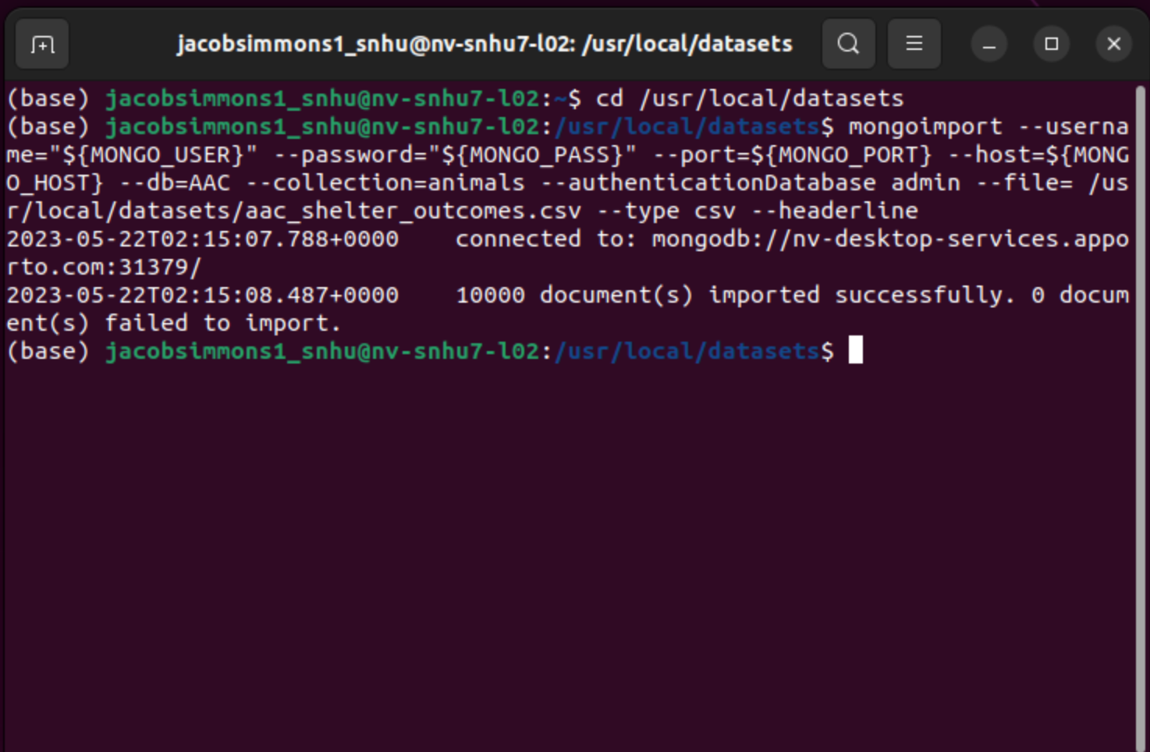

* **Create a simple index and use explain function to verify that the index will be used.**

Enter Mongo Shell and locate AAC dbs

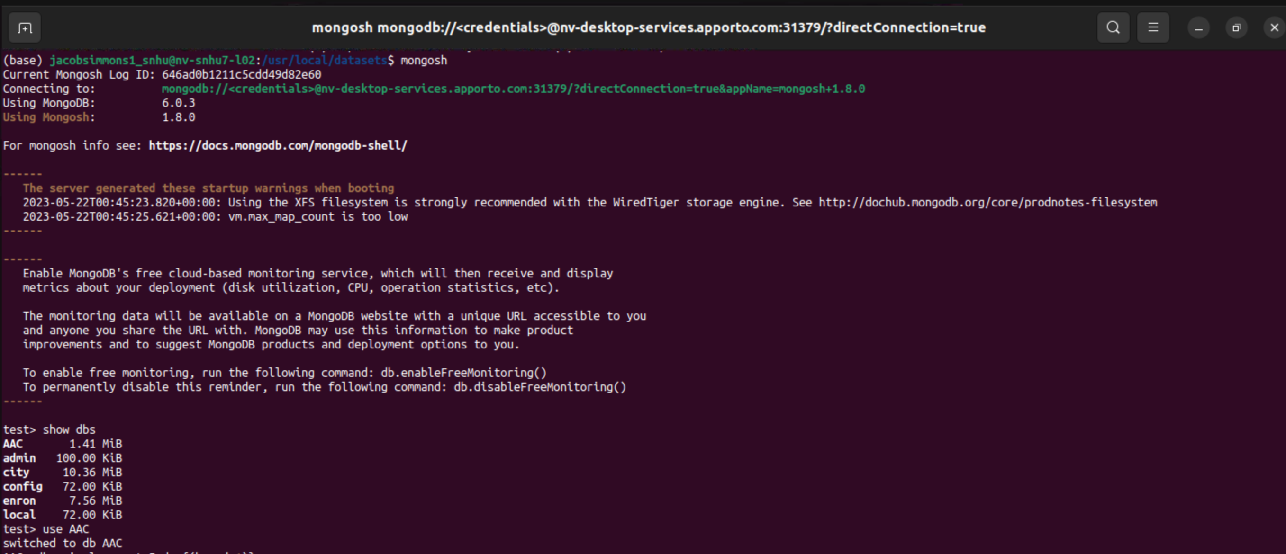

simple index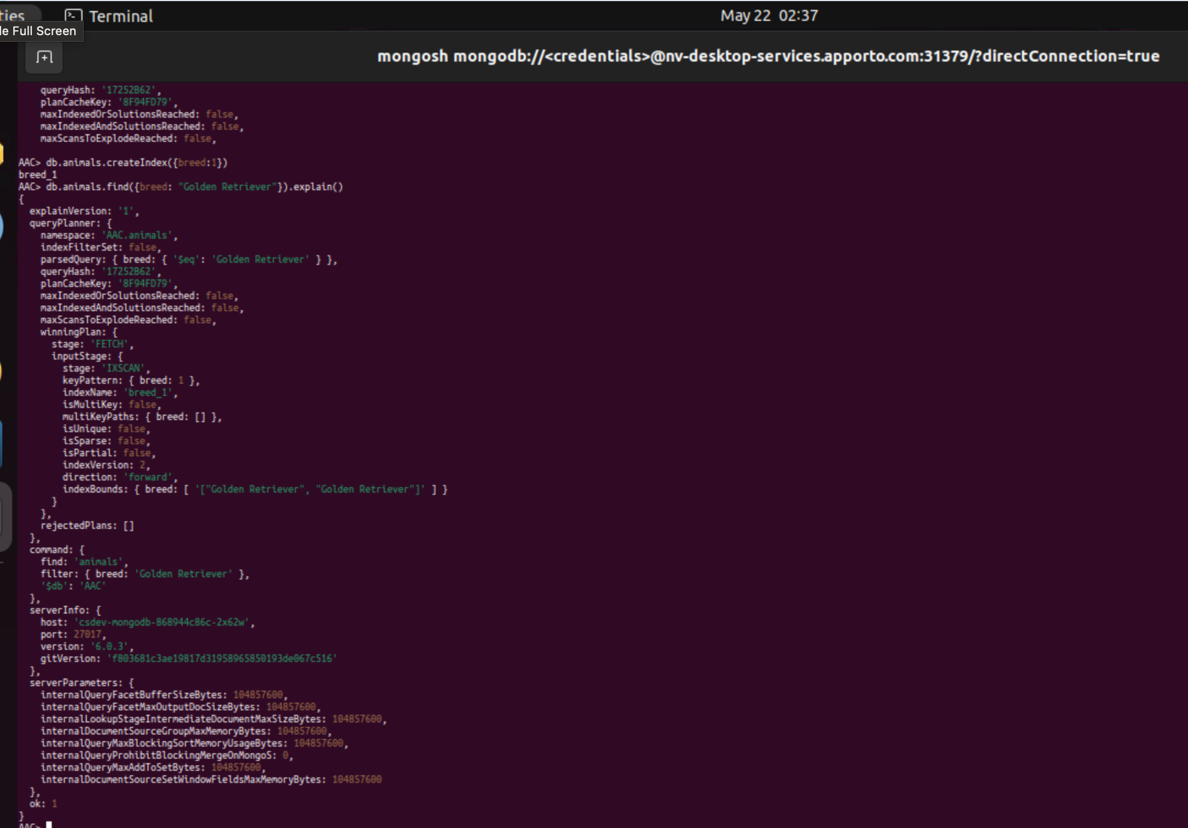

* **Create a compound index and use explain function to verify that the index will be used.**

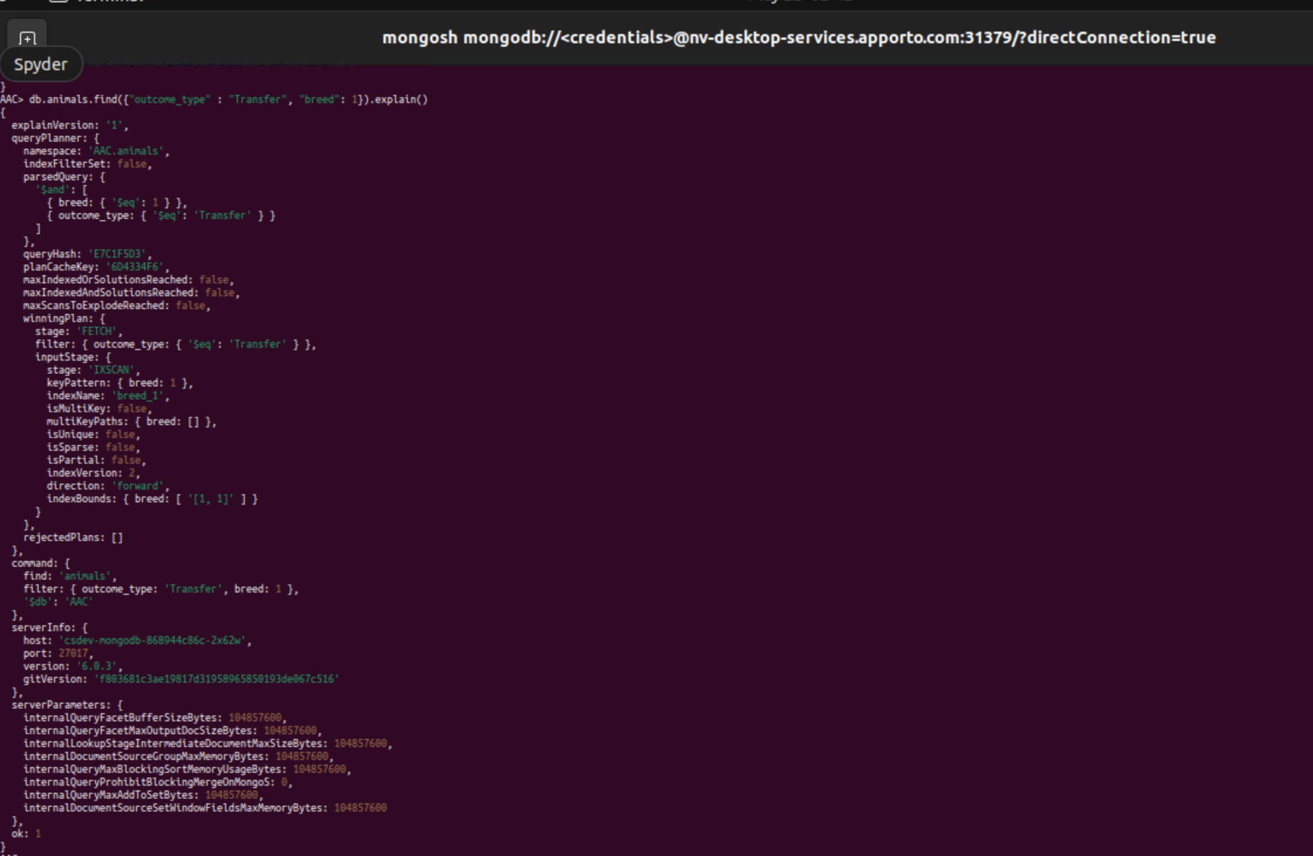

**Part II**

* **Create a new user account called “aacuser”**

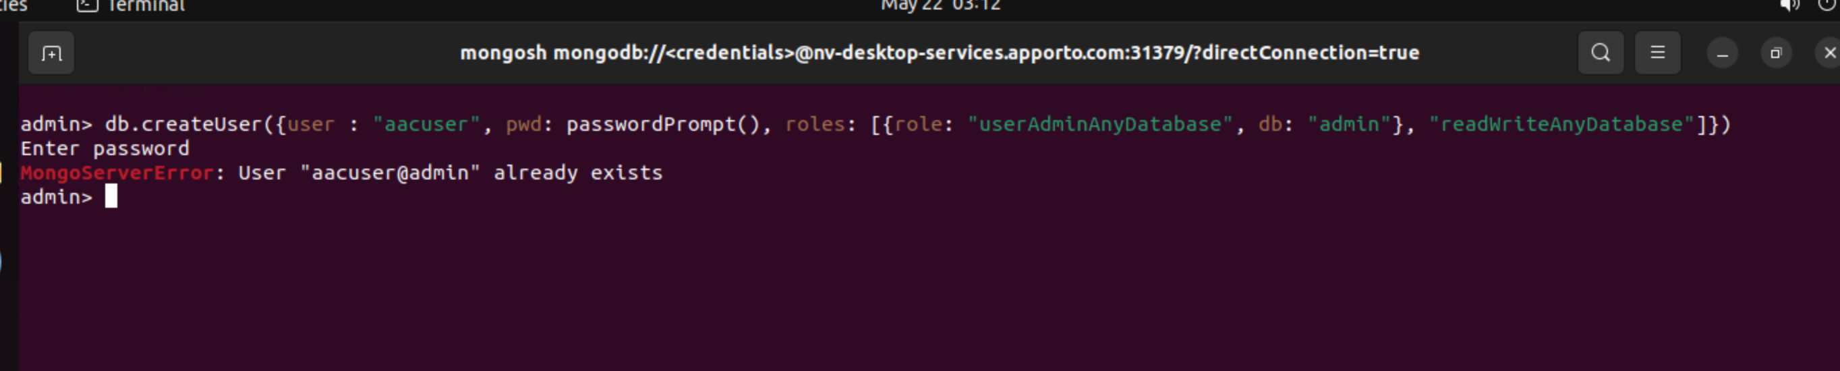

* **Take a screenshot of your login process to MongoDB using the mongo shell.**

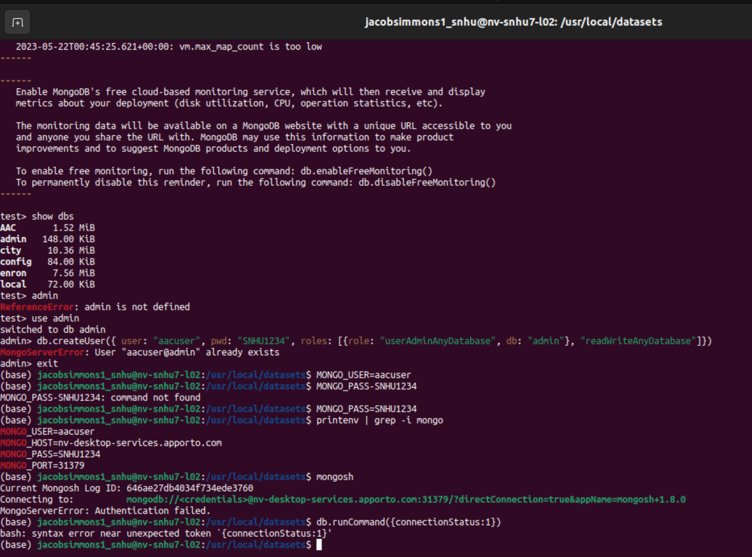

**References**

None